Mock file object for Unit Tests
Scenario
You are tasked to write a unit test code for the below scenario.
The application in which you are teamed up with, deals with the file system and it searches for files and retrieves files under the specified path. In the existing system, Directory.GetFiles() method has been used. You found that it’s not good idea to use Directory.GetFiles from the System.IO being its static and unable to unit test such methods.
After investigating the problem scenario, you found a solution and that is refactoring the code. Instead of using directly the static method Directory.GetFiles, you decided to create your own implementation to the method so that be able to mock files in the Unit Tests.
Task1
- Create a Class Library (Language C#) project using Visual Studio IDE, and name it as MagicFilesLib.
- Rename the default Class1 class name as DirectoryExplorer and include the following code snippet into it.
- Include the following namespaces with ‘using’ directive.
  - System.Collections.Generic
  - System.IO
- Define an interface as follow.
public interface IDirectoryExplore{
ICollection<string> GetFiles(string path);
}
- And provide implementation of IDirectoryExplorer in the DirectoryExplorer class as seen below.
namespace MagicFilesLib{
public class DirectoryExplorer: IDirectoryExplore{
public ICollection<string> GetFiles(string path) {
string[] files = Directory.GetFiles(path);
return files;
}
Aim
To create a Class Library project named MagicFilesLib and implement a custom file retrieval mechanism using an interface so that the functionality can be unit tested using mocking frameworks.
Project Structure
- MagicFilesLib
IDirectoryExplorer.cs
DirectoryExplorer.cs
MagicFilesLib.csproj

Interface: IDirectoryExplorer
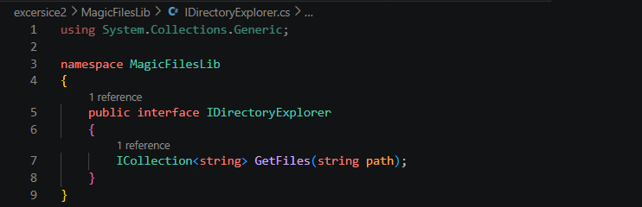

Class: DirectoryExplorer
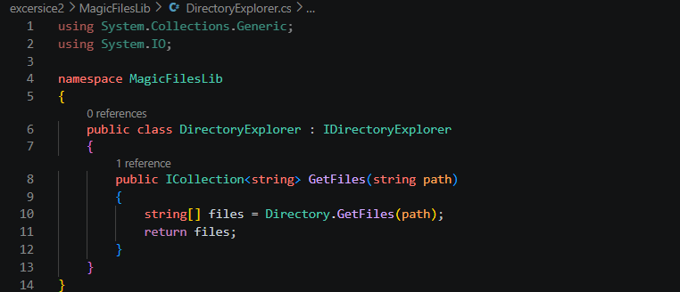

IDirectoryExplorer interface defines a contract for retrieving files from a specified path.
DirectoryExplorer implements the interface and internally uses Directory.GetFiles() to retrieve files from the file system.
This design enables dependency injection and mocking during unit testing.

Build Output:
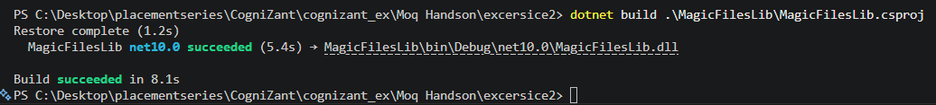

Conclusion
- Successfully created the MagicFilesLib Class Library project.
- Implemented IDirectoryExplorer interface and DirectoryExplorer class.
- The project was built successfully and is ready for unit testing using NUnit and Moq.

Task2 Mock File Object for Unit Tests using NUnit and Moq
- Create a new class library project called DirectoryExplorer.Tests and add the following external dependencies to it using NuGet Package Manager.
  - NUnit
  - NUnit Test Adapter
  - Moq
- Add the references of assemblies as appropriate including MagicFilesLib.
- Write unit test code and mock the DirectoryExplorer (IDirectoryExplorer), which is the class under test, with some hard coded file names.
- Use TestFixture, OneTimeSetUp and TestCase attribute classes on top of test class, init method and test method respectively.
- Add the following declarations in the test class.
private readonly string _file1 = "file.txt";
private readonly string _file2 = "file2.txt";
- In the test method, assert the following so that,
the collection is not null
the collection count is equal to 2
the collection contains _file1

Aim
To perform unit testing of the DirectoryExplorer class using NUnit and Moq by mocking the file retrieval functionality.
Project Structure
DirectoryExplorer.Tests:
── DirectoryExplorerTests.cs
── DirectoryExplorer.Tests.csproj
Required NuGet Packages
- NUnit
- NUnit3TestAdapter
- Moq
- Microsoft.NET.Test.Sdk

Test Class(DirectoryExplorerTests.cs.)
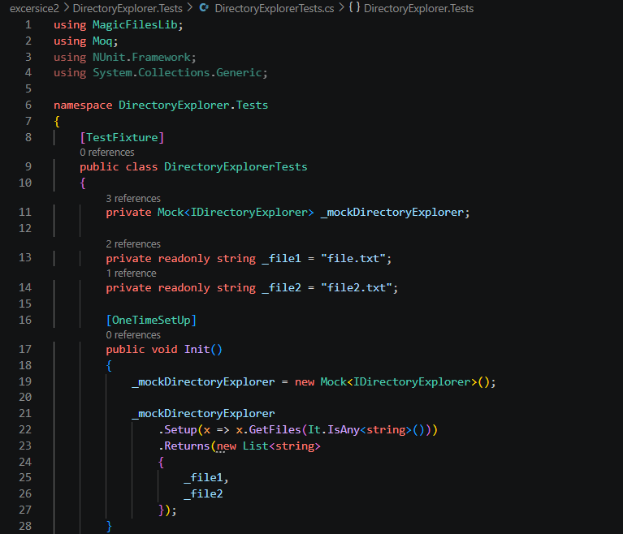
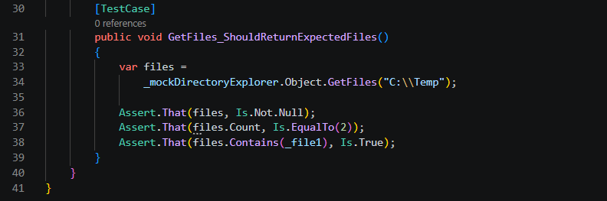

Test Execution Output:
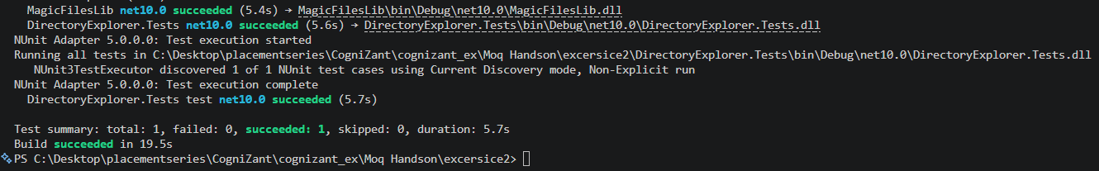

Conclusion
- Successfully mocked the IDirectoryExplorer interface using Moq.
- Performed unit testing without accessing the actual file system.
- All test cases executed successfully.

